Knowledge Record Sheet (1)
Manchester in the Industrial Revolution (For use with lessons 1 – 6)

This Knowledge Record Sheet relates to the Teaching Activity: What was Manchester like in the Industrial Revolution?
Lesson | What do you know? | What would you like to know?
1
2
3
Knowledge Record Sheet (2)
Manchester in the Industrial Revolution

TOUR
4
5
6
Interpretations Table
Interpretations of the Industrial Revolution in Manchester
(For use with lessons 1 and 2)

This Interpretations Table relates to the Teaching Activity: What was Manchester like in the Industrial Revolution?
 | Source 1: Danny Boyle’s interpretation. (Pandemonium) | Source 2: Friedrich Engels’ interpretation | Source 3: Johanna Schopenhauer’s interpretation
What does the source tell you about the Industrial Revolution? (What can you see, hear read?)
What interpretation is being given?
(What is the person trying to say about what the Industrial Revolution was like?

Homework Sheet
What can maps of Manchester in the 1700s and 1800s tell us about the city at this time?
(For use with lesson 1)

Go to the website http://manchester.publicprofiler.org/. Click on the icon “20 Historical Maps of Manchester (side by side)”. You should then see two maps of the centre of Manchester on your screen.

Activity 1:
On the list of maps on the left hand side select “Tinkler (1772)”.
On the list of maps on the right hand side, select “Slater 1848”.

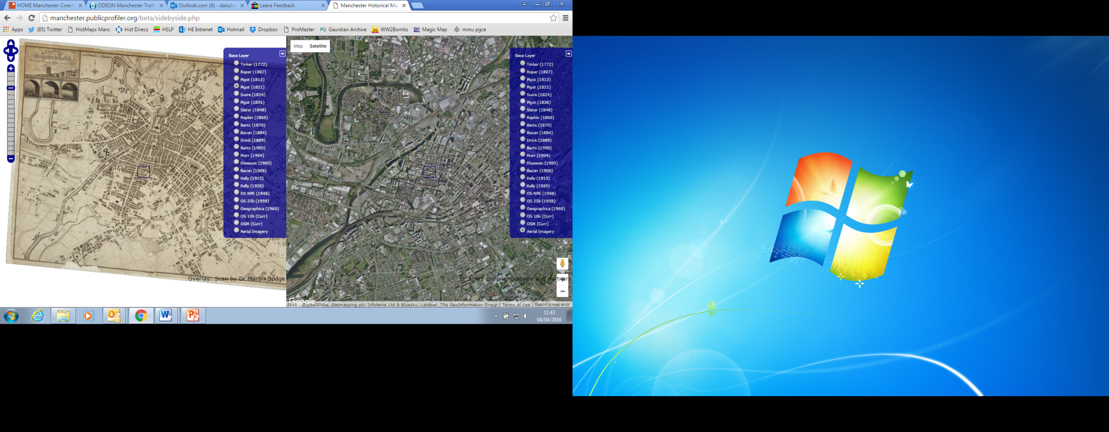
Tinkler 1772
Slater 1848

Complete the activities on the accompanying sheet to investigate the similarities and differences between the two maps.

Homework Sheet (2)
What can maps of Manchester in the 1700s and 1800s tell us about the city at this time?
(For use with lesson 1)
Activity 1
1772
1848
Both
B) What do your findings suggest about what happened in Manchester between 1772 and 1848?
____________________________________________________________________________________________________________________________________________________________________________________________________________________________________________________________________________________________________________________________________________________________________________________________________________________________________________________________________________________________________
A) Study the 1772 map and the 1848 map carefully.

In the left circle write down as many features as you can that appear only on the 1772 map.

In the right circle write down as many features as you can that appear only on the 1848 map.

In the central section write down as many features as you can that appear on both maps.

Can you write at least 5 things in each shape?

What can maps of Manchester in the 1700s and 1800s tell us about the city at this time?
(For use with lesson 1)
Homework Sheet (3)

Activity 2:
Select the Barts 1870 map from the list of maps on the left hand side.
- Find Ancoats and list 3 street names from this area.
TIP: You can zoom in and out of the maps using the icon in the top left corner of the screen

_________________________________
_________________________________
_________________________________
- Find Thomas Street and name two roads coming off it
_________________________________
_________________________________

(Hint. You might find it easier to locate both areas on the old maps by finding them on Google Maps first. Ancoats is marked in larger, capital letters and Thomas Street it is quite close to the Infirmary, marked in green on the map)

Assessment Writing Frame
‘Mills and factories were the only basis for the Industrial Revolution in Manchester’. To what extent do you agree with this statement? (for use in lesson 6)

 | Word bank
Many people think that the Industrial Revolution in Manchester was characterised by the production of goods in mills and factories and by extremes of rich and poor. In this essay I will consider to what extent this is an accurate and complete? Picture of Manchester during this period.
The traditional interpretation of Manchester during the Industrial Revolution is…..  - Write at least three paragraphs describing the traditional interpretation of the Industrial Revolution  - Where were goods made?  - What was it like for workers?  - Who made all the money? | Mills  Factories  Mass production  Manufacture  Poverty | Wealth  Polarized  Exploit / exploitation
Having carried out further research, however, it is clear that this traditional interpretation doesn’t fully describe what Manchester was like during this time. In fact, if we look at Thomas Street in the Northern Quarter, it can be seen that…..  - Write at least three paragraphs describing your findings from looking at Thomas Street. If you can, try to mention some of the sources you used.  - What sorts of businesses were there on Thomas Street?  - How rich or poor were the people who lived there?  - How did people spend their money in Manchester? | Trade  Workshop  Small scale production  Middle class  Consumer / consumerism  Disposable income  Mixed society
In conclusion, the traditional interpretation is not at all / partly / mostly accurate to describe Manchester during the Industrial Revolution, however, research suggests that there was more going on at this time…..
- Write 3 or 4 sentences summing up your findings and what you have written in this essay.

Useful linking words
- However  - Nevertheless  - Therefore | - Furthermore  - Moreover  - In addition | - As opposed to  - Finally  - In conclusion
Assessment Mark Scheme
‘Mills and factories were the only basis for the Industrial Revolution in Manchester’. To what extent do you agree with this statement? (for use in lesson 6)

Please note. This is a sample mark scheme based on the system used at Stretford Grammar. You may need to be adjust it in line with your school’s marking policy

Level 4
- Pupils describe the lives of the people of Thomas Street and those working in the mills.
- They can identify that people had different experiences but do not explain why.
- They begin to use their knowledge to test their ideas.
- Work is quite structured with appropriate use of dates and terms.

Level 5
- Pupils describe the lives of Manchester residents in the context of what was happening with regards to Industrialisation and living conditions. They appreciate that conditions were not the same for everyone.
- They begin to ask their own questions about the issues they have studied and test their own hypotheses.
- They begin to evaluate the sources that they have used.
- They can use accurate, technical vocabulary to create properly structured work.

Level 6
- Pupils begin to analyse the situations described and explore the sense of diversity.
- They link and evaluate sources to begin to explain how and why interpretations have varied and differed across time and place.
- They use an increasingly relevant and technical vocabulary to create a coherent and structured argument.

Level 7
- Pupils explain different interpretations in context.
- They refine the debate and create questions of their own which they begin to answer.
- They approach all sources critically and use the information to help refine their answer.
- The work is well organised with a sophisticated use of technical terms.

Assessment Mark Scheme
‘Mills and factories were the only basis for the Industrial Revolution in Manchester’. To what extent do you agree with this statement? (for use in lesson 6)

Level 8
- Pupils use all historical skills confidently and competently to offer and develop their own refined hypothesis on the topic. Language used is technical and sophisticated.
- They answer their own questions raised as a result of their research.
- They approach all sources critically and link to the wider context of nineteenth century

